
Lesson 8 – Containerization and Orchestration

Topics
- What is Containerization?
- Benefits of Containerization
- What is Container orchestration?
- Container Orchestration Tools
- Kubernetes
- Docker

- What is Containerization?
- Containerization is the process of packaging an application and all its dependencies, such as libraries, configuration files, and runtime, into a container.
- A container is a lightweight, standalone, and portable unit that ensures the application runs consistently across different environments, regardless of differences in the underlying infrastructure or operating system.

- What is Container orchestration?
Container orchestration is the automated process of managing, deploying, scaling, and networking containers across clusters of servers. It simplifies handling multiple containers in complex applications, ensuring they work together efficiently and reliably.
- Containerization and orchestration technologies
- Docker: For building and running containers.
- Kubernetes: For orchestrating and managing containers in a production environment.
- Podman: A Docker-compatible, rootless container engine focused on security.
- Containerd: A container runtime that powers tools like Docker and Kubernetes.
- AWS Fargate: A serverless container platform for running containers in AWS without managing infrastructure.
- What is Docker?
Docker is a containerization tool that enables developers to package an application and its dependencies into a single container.
- Why containerize(Dockerize) a React App?
Containerizing a React app with Docker offers several important advantages:
- Consistency Across Environments: Docker ensures the app runs the same way across development, staging, and production environments, minimizing environment-specific bugs.
- Easier Deployment: With Docker, deploying a React app becomes straightforward and flexible, allowing it to be hosted on cloud providers like AWS, Google Cloud, or Azure with minimal configuration.
- Dependency Isolation: Docker containers package all dependencies, making the app independent of the host system's configuration, reducing conflicts, and simplifying dependency management.
- Scalability: Docker enables easy scaling by running multiple instances (containers) in parallel, which improves load management and availability.

Activity 13 – Containerizing a React App

Step 1 – Installing the Docker Desktop on your computer.
  - Verify virtualization is enabled on your computer. If it is not, activate it from the BIOS settings.
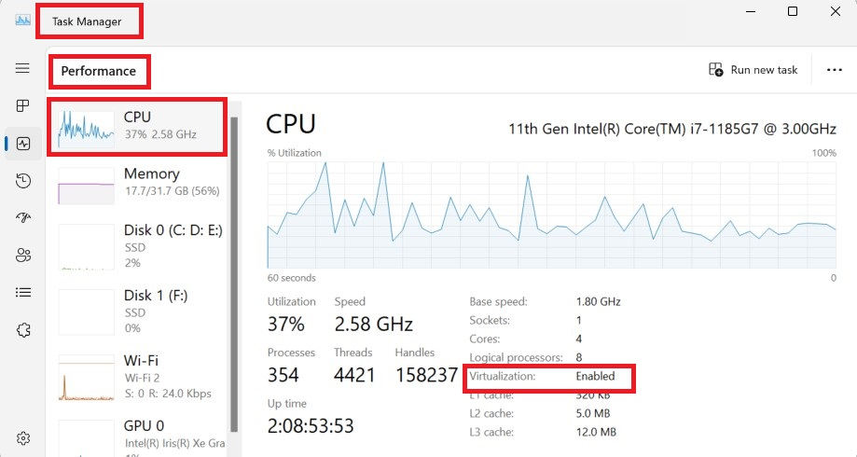
  - Install WSL (Windows Subsystem for Linux). It is a lightweight Linux runtime environment for Docker on Windows. Open PowerShell as Administrator and run the following command.
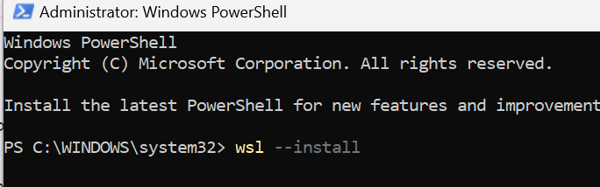

  - Download the Docker desktop from the website https://www.docker.com/products/docker-desktop/ and install it. Here, you need to have an user account.
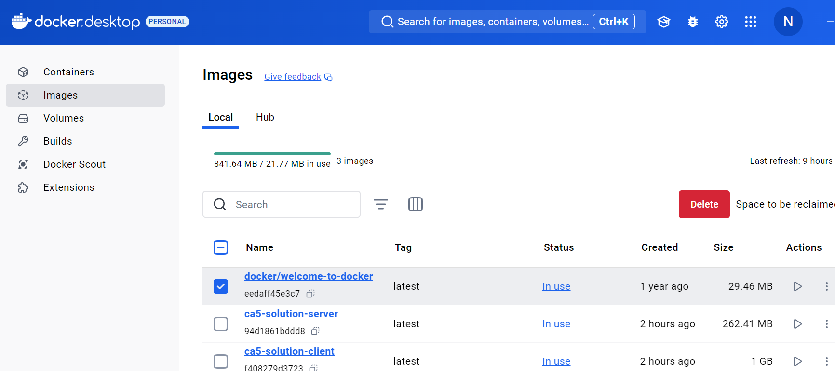

Step 2 - Create a .env file
Environmental variable file (.env) will help to avoid hard-coding sensitive parameters like port numbers, connection strings, and URLs.

Step 3 – Creating the Dockerfile for client
Docker uses a Dockerfile to define the environment for the React app. This file contains instructions for setting up the app within a container, such as installing Node.js, copying the app files, installing dependencies, and building the app.

- Create the Dockerfile at the React app folder and add the following code to the file. Open postITapp/client folder and create it. The commands in the file and explanation are given below.

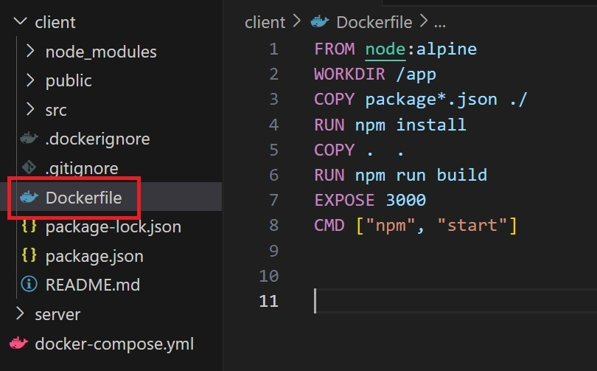

Command | Explanation
FROM node:alpine | Specifies the base image as Alpine Node.js.
WORKDIR /app | Sets the working directory inside the container to /app.
COPY package*.json ./ | Copies package.json and package-lock.json files to the container's /app directory.
RUN npm install | Installs the dependencies listed in the package.json file using npm.
COPY . . | Copies all the application files from the local directory to the container's working directory.
RUN npm run build | Builds the React application for production, generating static files in the build folder.
EXPOSE 3000 | Opens port 3000 in the container to allow external access to the app.
CMD ["npm", "start"] | Sets the default command to run the client app when the container starts.

- Create the .dockerignore at the React app folder(postITapp/client) and enter node_modules.
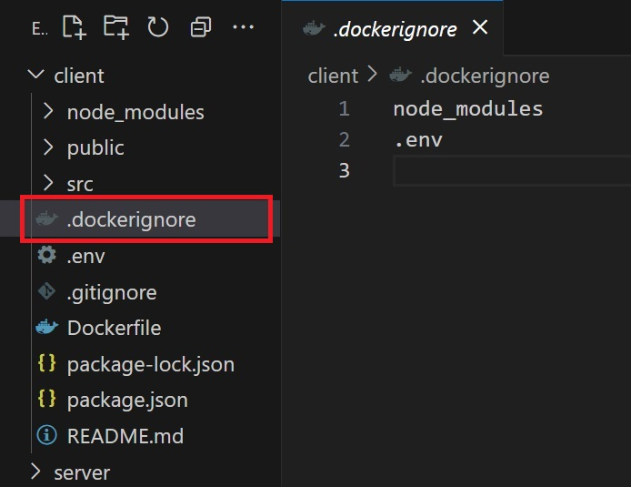
Step 4 – Creating the Dockerfile for server.
This activity designed for postITapp. You do it for your application.
- Open the folder postITapp/server and create the Dockerfile
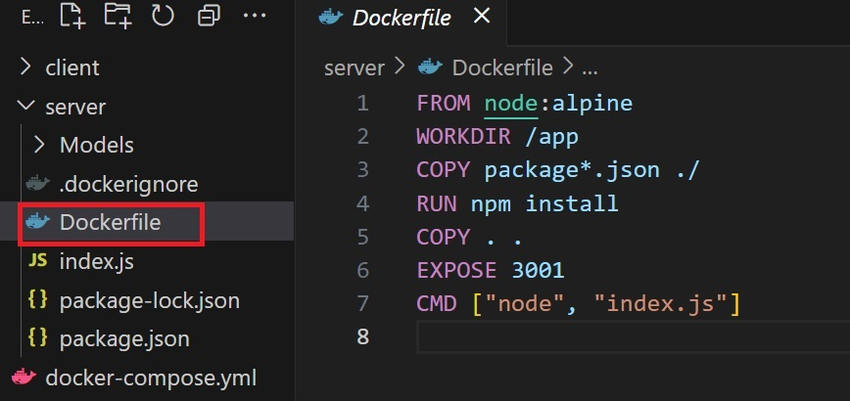
- Open the folder postITapp/server and create the .dockerignore
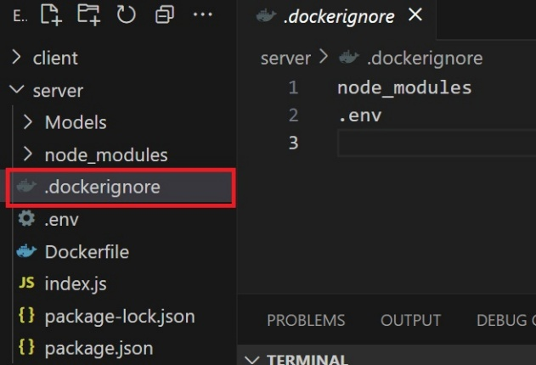

Step 5 – Creating the docker-compose.yml configuration file in the main folder(postITapp).
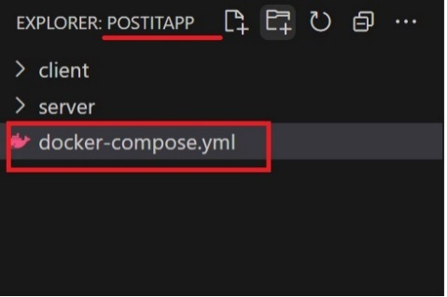
The docker-compose.yml file is a configuration file used with Docker Compose, a tool for defining and running multi-container Docker applications. This file allows you to specify all the services, networks, and volumes required for your application in a single YAML file. Specify the configuration in the YAML file. The following is the YAML file.

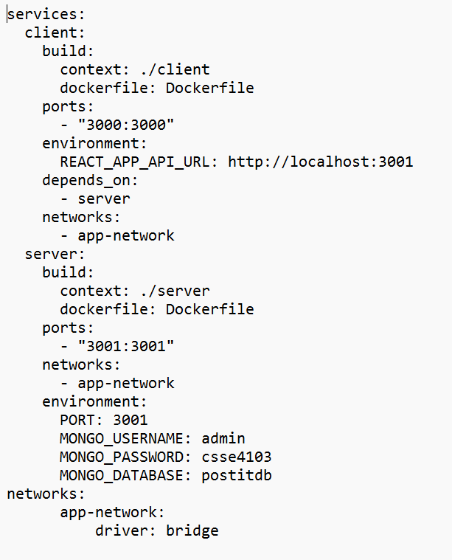

Step 6 - Running YAML file to build the container.
Open the root directory of the app in your terminal and execute the following command to run the docker-compose.yml file. The --build flag tells Docker Compose to rebuild the images before starting the containers.
docker-compose up --build

Once the containers are up and running, you can access the application by visiting http://localhost:3000/ in your web browser. Check the Docker images for client and server on the Docker Desktop.
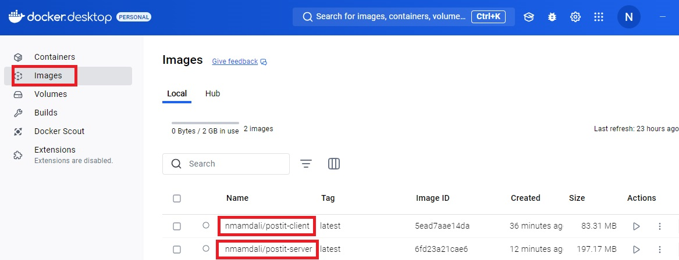

Check the Docker container for the app on the Docker Desktop. Here, you can start and stop the app.
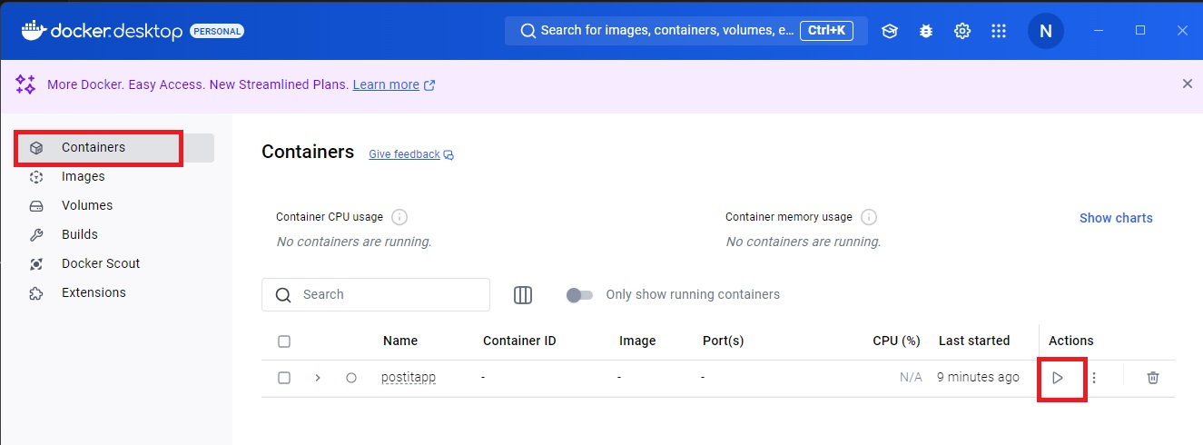

Step 7 – Push the docker images to Docker hub.
The docker push command is used to upload a Docker image from your local Docker environment to a container registry (Docker Hub) for deploying the app to the cloud hosting platform.

- Make sure you are logged into Docker Desktop on your local machine.

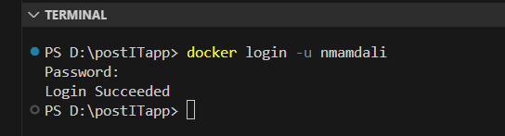
- Tag the Docker Image from the terminal.

Syntax
docker tag <local-image-name>:<tag> <dockerhub-username>/<repository-name>:<tag>

docker tag postitapp-server:latest nmamdali/postitapp-server:latest

docker tag postitapp-client:latest nmamdali/postitapp-client:latest

- Push the Docker Image from the terminal. Use the docker push command to upload the image to Docker Hub.

docker push nmamdali/postitapp-server:latest
docker push nmamdali/postitapp-client:latest

- Open dockerhub and see the repositories where you can find the images that you pushed from your machine.( https://hub.docker.com/)

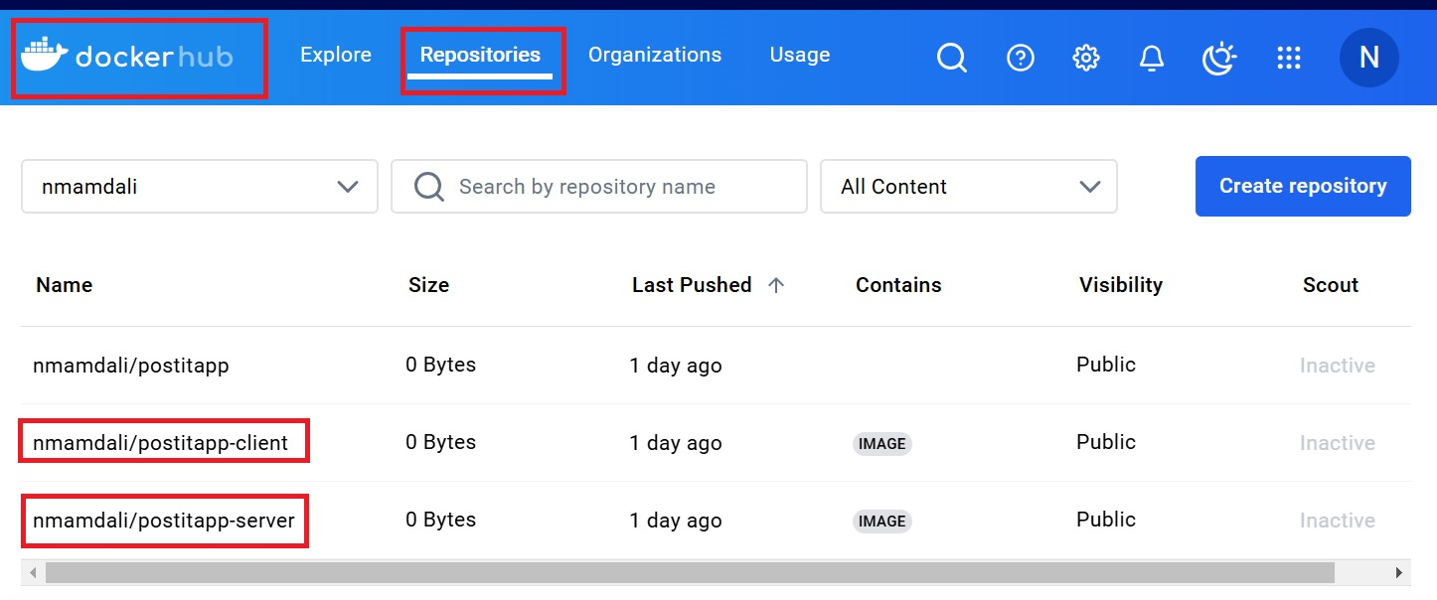

Once your Docker image is pushed to Docker Hub, you can:
- Share & Collaborate: Share the image for team use or public access.
- Deploy: Use the image for deployment on servers, Kubernetes, Docker Compose, or cloud platforms.
- Run Anywhere: Pull and run the image on any machine with Docker installed.
- Automate CI/CD: Integrate the image into CI/CD pipelines for testing and deployment.
- Backup: Keep the image as a reliable backup of your application.
- Showcase Public Projects: Host public repositories to share or demonstrate projects.
- Integrate with Tools: Link Docker Hub to platforms like Kubernetes, Jenkins, or monitoring tools.

This makes the image accessible, portable, and ready for use in multiple environments.

